# Tutorial: Setting Up a Maven Project (IntelliJ IDEA)

## Step 1: Creating a New Maven Project

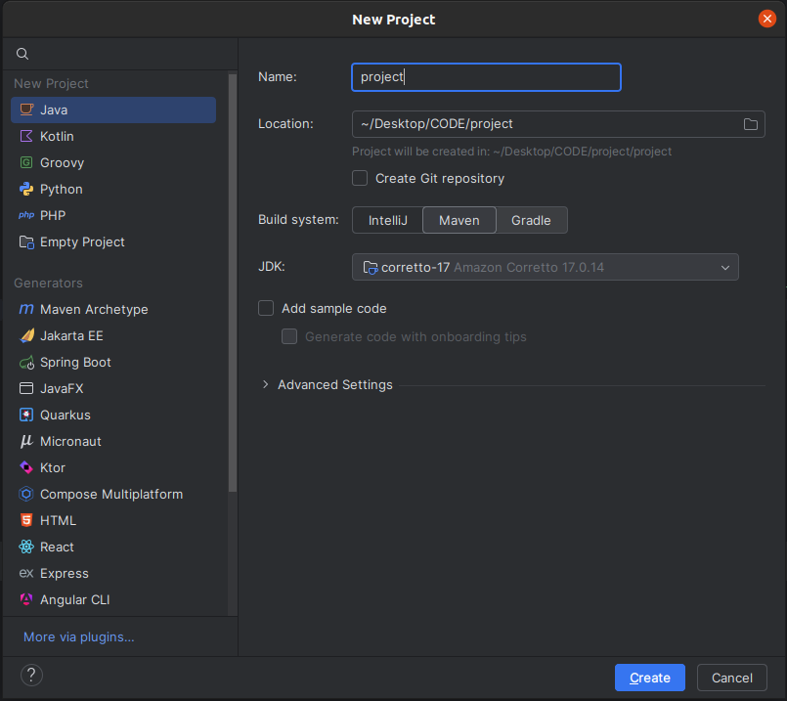

1. Open IntelliJ IDEA.

2. Navigate to File > New > Project.

3. In the 'New Project' window:

- Select 'Java'.

- Set 'Name' to: project.

- Choose 'Maven' as the Build System (Maven is a project management tool that automates the build process).

- Select JDK 17 (JDK is required for compiling Java code. You may need to install it from IntelliJ).

4. Click 'Next' and then 'Finish' to create the project.

⚠ Ensure JDK 17 is used for consistency in future labs.

## Step 2: Adding JUnit 5 Dependencies

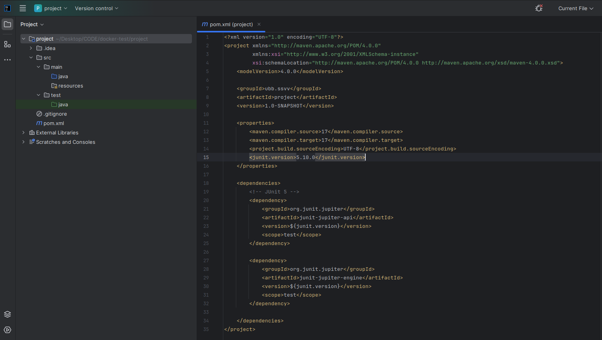JUnit 5 is a testing framework for Java applications.

To add JUnit 5 to the project:

1. Open the pom.xml file (Maven's configuration file).

2. Add the following dependencies:  
<properties>  
 <junit.version>5.10.0</junit.version>  
</properties>  
  
<dependencies>  
 <!-- JUnit 5 -->  
 <dependency>  
 <groupId>org.junit.jupiter</groupId>  
 <artifactId>junit-jupiter-api</artifactId>  
 <version>${junit.version}</version>  
 <scope>test</scope>  
 </dependency>  
 <dependency>  
 <groupId>org.junit.jupiter</groupId>  
 <artifactId>junit-jupiter-engine</artifactId>  
 <version>${junit.version}</version>  
 <scope>test</scope>  
 </dependency>  
</dependencies>

## Step 3: Adding Allure Dependencies

A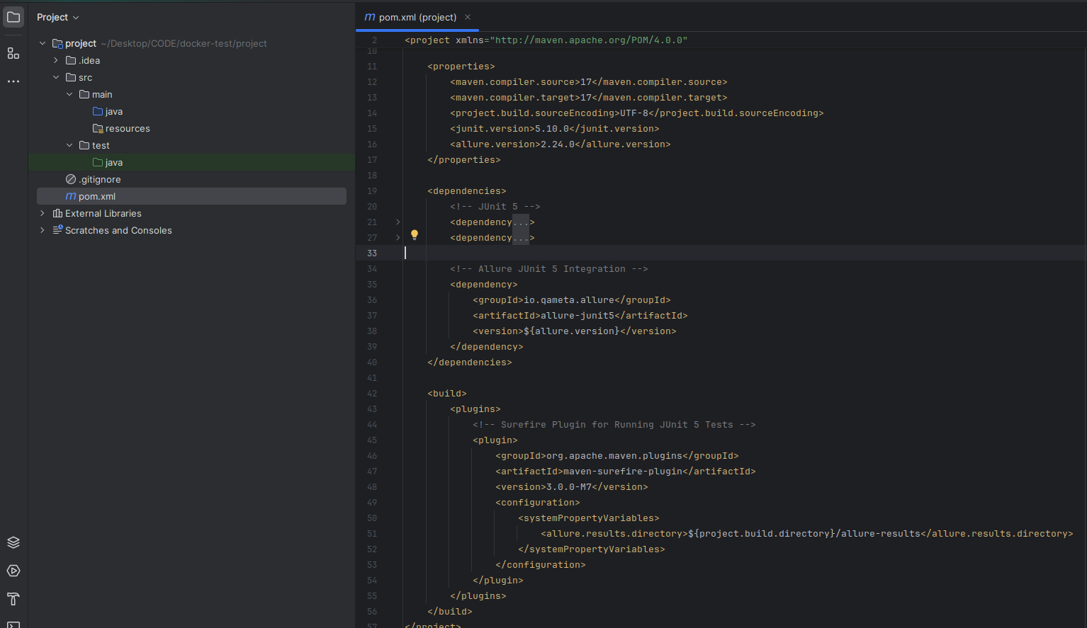llure is a reporting tool for test execution results.

To integrate Allure with JUnit 5:

1. Open the pom.xml file.

2. Add the following configuration:

<properties>  
 <allure.version>2.24.0</allure.version>  
</properties>  
  
<dependencies>  
 <!-- Allure JUnit 5 Integration -->  
 <dependency>  
 <groupId>io.qameta.allure</groupId>  
 <artifactId>allure-junit5</artifactId>  
 <version>${allure.version}</version>  
 </dependency>  
</dependencies>  
  
<build>  
 <plugins>  
 <!-- Surefire Plugin for Running JUnit 5 Tests -->  
 <plugin>  
 <groupId>org.apache.maven.plugins</groupId>  
 <artifactId>maven-surefire-plugin</artifactId>  
 <version>3.0.0-M7</version>  
 <configuration>  
 <systemPropertyVariables>  
 <allure.results.directory>${project.build.directory}/allure-results</allure.results.directory>  
 </systemPropertyVariables>  
 </configuration>  
 </plugin>  
 </plugins>  
</build>

## Step 4: Organizing the Maven Project Structure

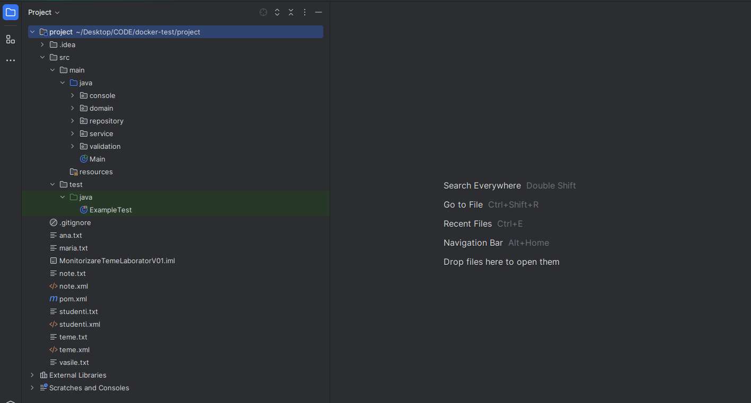

Maven follows a structured project layout:

- Place business logic classes under src/main/java.

- Place test classes under src/test/java.

- Store static files (e.g., XML configurations) in the root of the project.

- Include a .gitignore file in the project root.

## Step 5: Running the Main Class

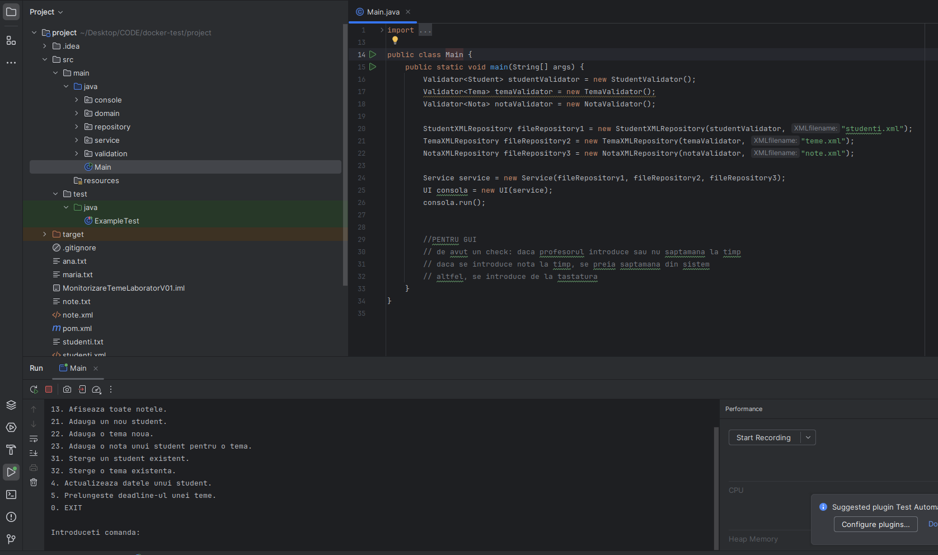

To validate that the project starts successfully:

1. Open src/main/java/Main.java.

2. Run the main method from IntelliJ to confirm the project setup.

## Step 6: Running Example Test

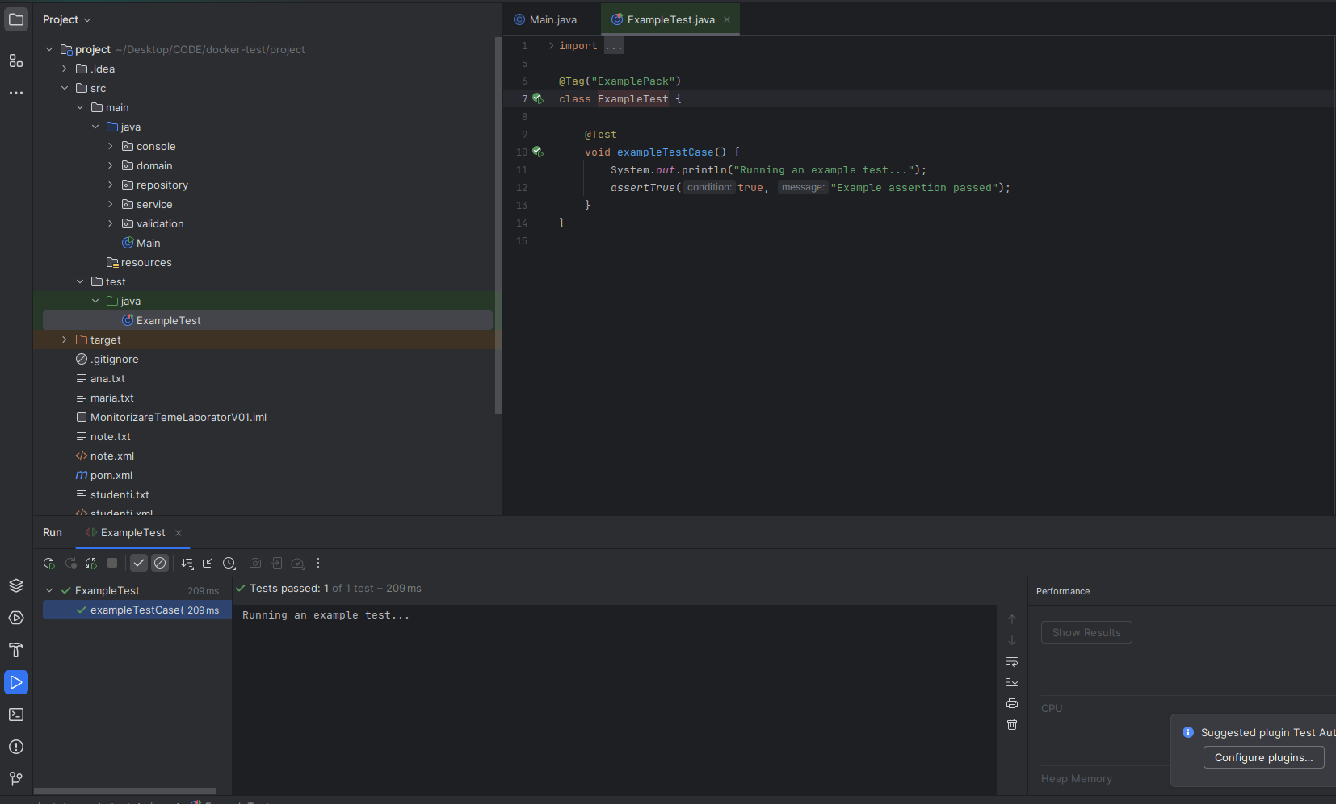

To verify that JUnit 5 tests run correctly:

1. Open src/test/java/ExampleTest.java.

2. Execute the test from IntelliJ or using Maven with `mvn test`.