# Setting Up a CI/CD Workspace with Docker, Gitea, Jenkins, and Allure

This tutorial guides you through setting up a complete CI/CD environment using Docker, Gitea (a self-hosted Git service), Jenkins (automation server), and Allure (test reporting tool). By the end of this tutorial, you will have a running workspace capable of building and testing Maven projects with automated reports.

## Prerequisites

Ensure you have the following installed:

• Docker and Docker Compose (Installation depends on OS)

## Step 1: Setting Up Docker Compose

Create a new directory for your workspace:

```bash  
mkdir -p ~/Desktop/vvss/workspace && cd ~/Desktop/vvss/workspace  
```

Create a `docker-compose.yml` file with the following content:

```yml  
services:  
 jenkins:  
 build:   
 context: .  
 dockerfile_inline: |  
 FROM jenkins/jenkins:lts  
 USER root  
 RUN apt-get update && apt-get install -y maven tree  
 RUN jenkins-plugin-cli --plugins allure-jenkins-plugin:2.32.0 workflow-aggregator:600.vb_57cdd26fdd7 matrix-project:845.vffd7fa_f27555 git:5.7.0   
 RUN mkdir -p /usr/share/jenkins/ref/init.groovy.d && echo 'import jenkins.model.*' > /usr/share/jenkins/ref/init.groovy.d/allure_init.groovy && echo 'import hudson.tools.*' >> /usr/share/jenkins/ref/init.groovy.d/allure_init.groovy && echo 'import ru.yandex.qatools.allure.jenkins.tools.*' >> /usr/share/jenkins/ref/init.groovy.d/allure_init.groovy && echo 'def desc = Jenkins.instance.getDescriptor(AllureCommandlineInstallation.class)' >> /usr/share/jenkins/ref/init.groovy.d/allure_init.groovy && echo 'def installer = new AllureCommandlineInstaller("2.32.2")' >> /usr/share/jenkins/ref/init.groovy.d/allure_init.groovy && echo 'def installSourceProperty = new InstallSourceProperty([installer])' >> /usr/share/jenkins/ref/init.groovy.d/allure_init.groovy && echo 'def installation = new AllureCommandlineInstallation("allure", "", [installSourceProperty])' >> /usr/share/jenkins/ref/init.groovy.d/allure_init.groovy && echo 'desc.setInstallations(installation)' >> /usr/share/jenkins/ref/init.groovy.d/allure_init.groovy && echo 'desc.save()' >> /usr/share/jenkins/ref/init.groovy.d/allure_init.groovy  
 USER jenkins  
 container_name: jenkins  
 restart: always  
 ports:  
 - "8080:8080"  
 - "50000:50000"  
 volumes:  
 - './jenkins_data:/var/jenkins_home'   
  
 gitea:  
 image: gitea/gitea:latest  
 container_name: gitea  
 restart: always  
 ports:  
 - "3000:3000"  
 - "2222:22"  
 volumes:  
 - './gitea_data:/data'  
 environment:  
 - USER_UID=1000  
 - USER_GID=1000  
 - GITEA__database__DB_TYPE=sqlite3  
 - GITEA__server__DISABLE_REGISTRATION=true  
 - GITEA__security__INSTALL_LOCK=true  
 - GITEA__server__ROOT_URL=http://gitea:3000/  
```

## Step 2: Running Docker Compose

Open a terminal in the docker-compose.yml parent folder and start the services by running:

```bash  
docker compose up  
```

This will create Dockerized instances of Jenkins (pre-configured with java 17, Maven and Allure) and Gitea (our self-hosted github alternative)

## Step 3: Setting Up Gitea

Access Gitea by navigating to `[http://localhost:3000](http://localhost:3000/)`.

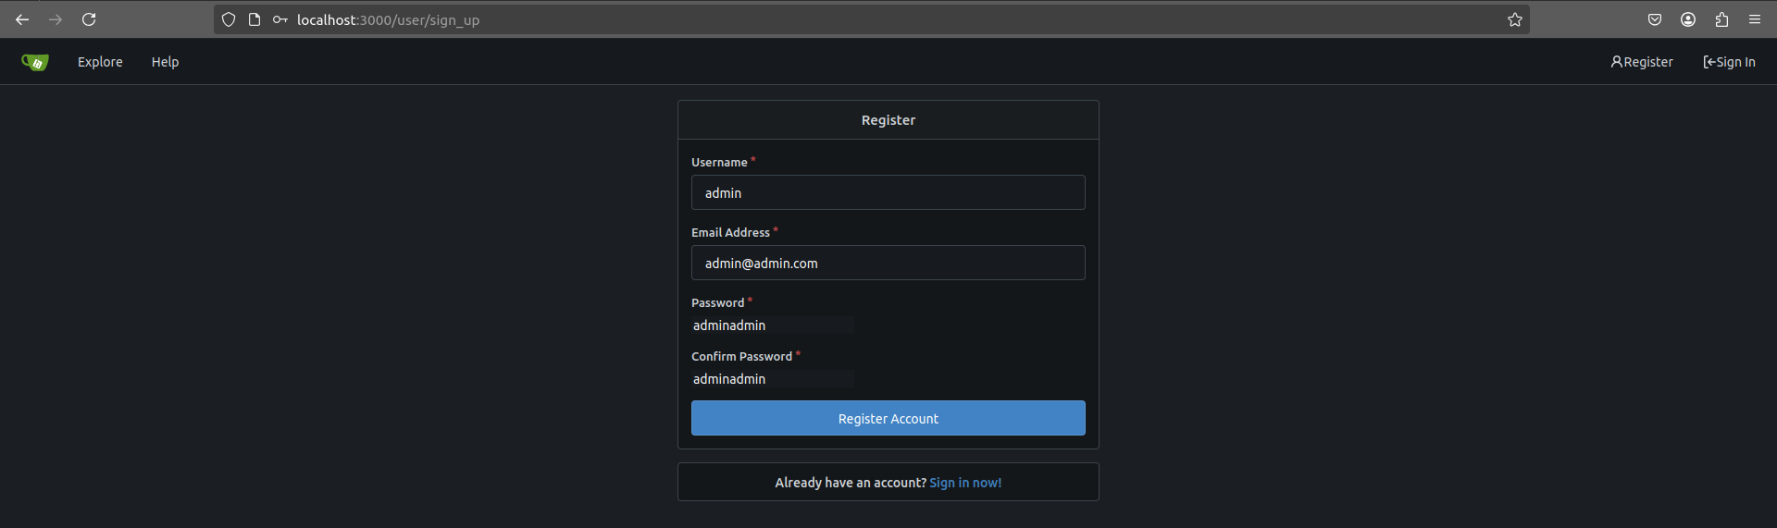

Register an account with:

• Username: admin

• Password: adminadmin

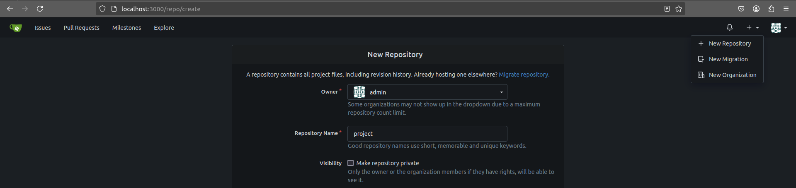

Create a new public repository named ‘project’

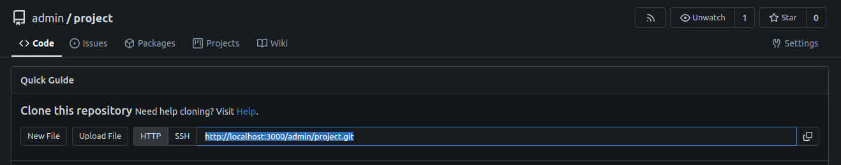

Clone the repository locally:

```bash  
git clone http://localhost:3000/admin/project.git  
```

Move all your project files in the empty repository

Push all the project files to the repository

```bash  
git add . && git commit -m “base” && git push  
```

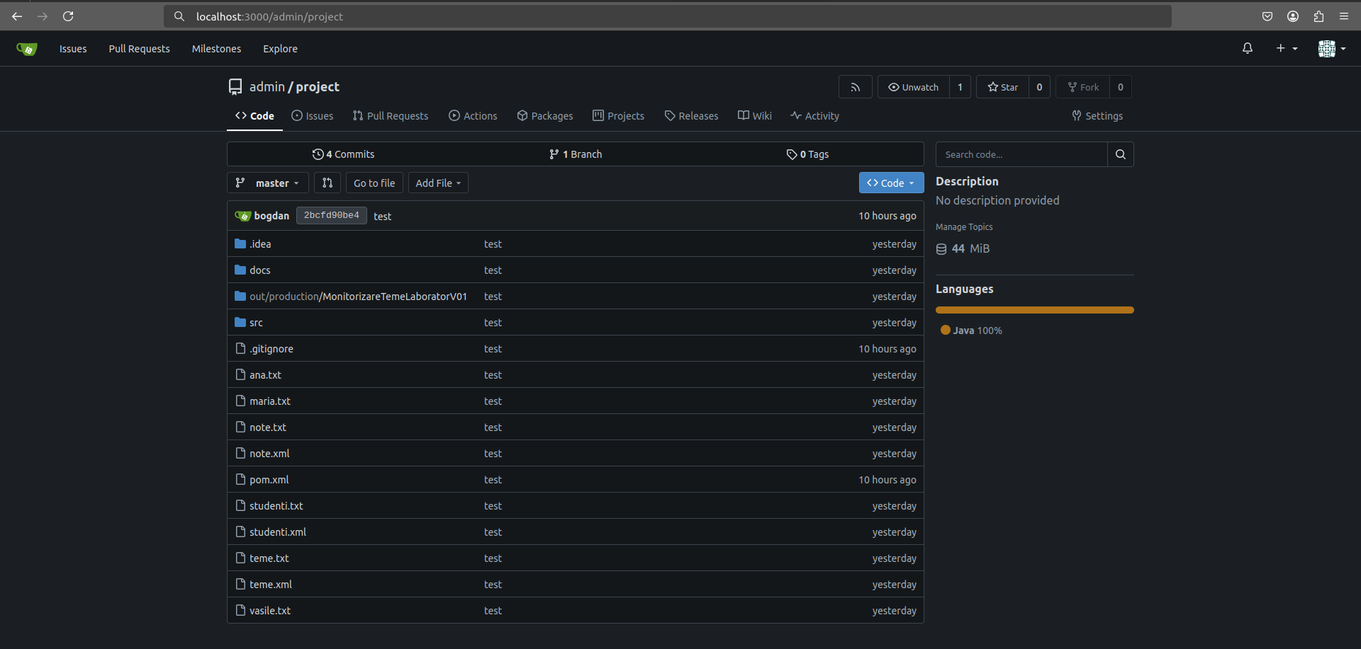

## Step 4: Setting Up Jenkins

Access Jenkins at `[http://localhost:8080](http://localhost:8080/)`. No username required, default is `admin`.

## Step 5: Creating a Pipeline Job

Create a new Jenkins Item (job)

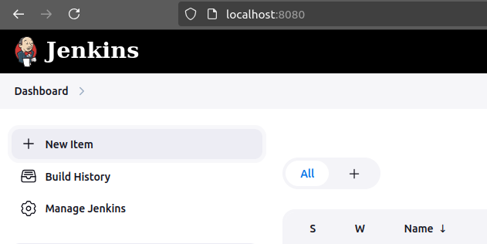Name: tests & Item Type: Pipeline

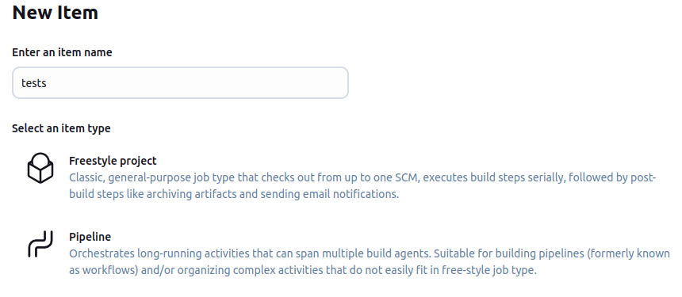

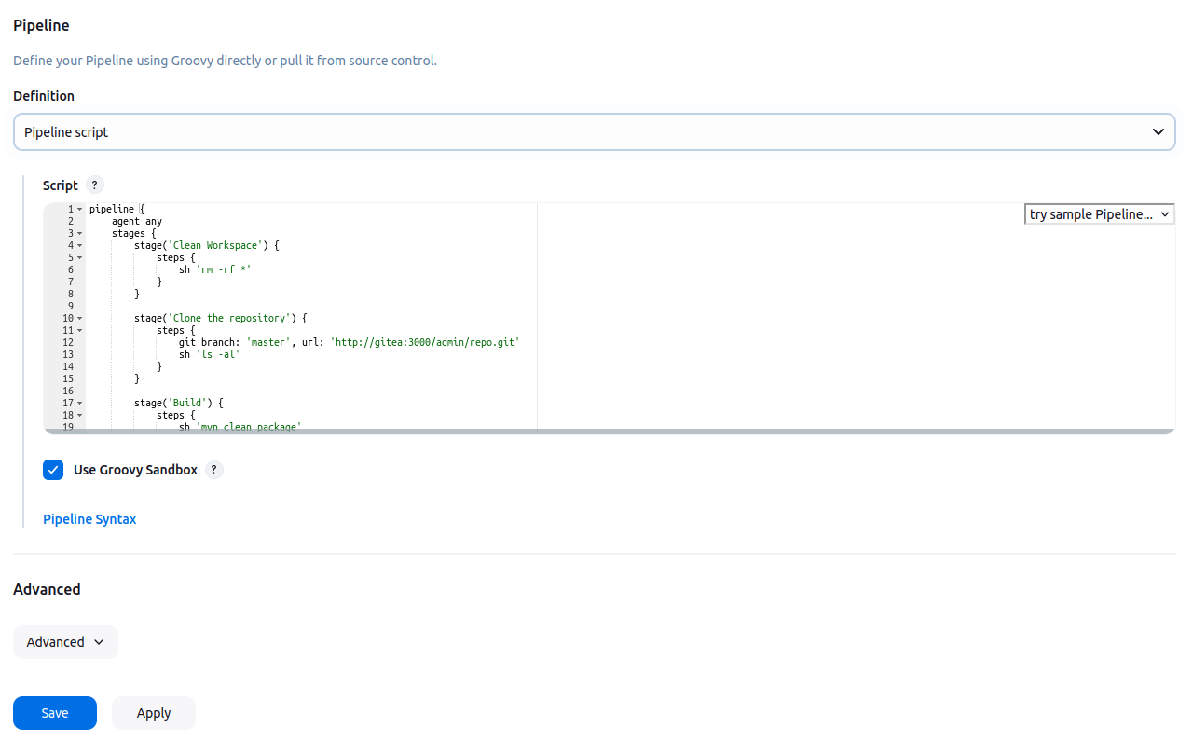Configure the pipeline definition as: Pipeline Script

and use the following script:

```groovy  
pipeline {  
 agent any  
 stages {  
 stage('Clean Workspace') {  
 steps {  
 sh 'rm -rf *'  
 }  
 }  
   
 stage('Clone the repository') {  
 steps {  
 git branch: 'master', url: 'http://gitea:3000/admin/repo.git'  
 sh 'tree'  
 }  
 }  
   
 stage('Build') {  
 steps {  
 sh 'mvn clean install -DincludeTags=ExamplePack'  
 }  
 }  
   
 stage('Publish Allure Report') {  
 steps {  
 allure includeProperties: false, jdk: '', results: [[path: 'target/allure-results']]  
 }  
 }  
 }  
}  
```

Take some time to inspect the steps of the pipeline.

Note down in your own words what you think it’s doing.

Apply & Save

## Step 6: Running the Pipeline

Click on 'Build Now' in Jenkins to run the pipeline.

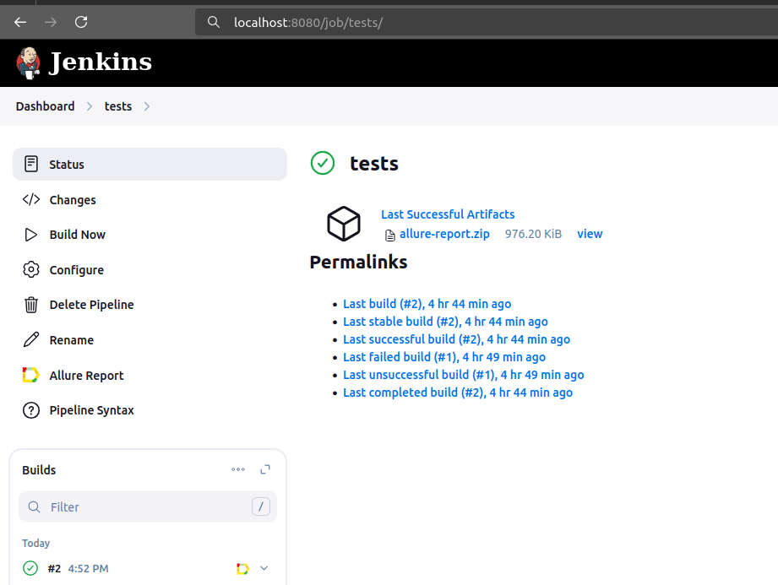

Fingers crossed for the execution to be ‘green’ (successful)

## Step 7: Viewing Allure Reports



Once the pipeline completes, navigate to the Allure Reports to view detailed test results grouped by tags.